**Final Report**

**PROJECT TITLE**

Employee Management System (EMS)



**PROJECT MENTOR**

Ahsan Ali

**GROUP MEMBERS**

Akash Samuel Khokhar

Chander Harwani

Talha Khan

Ramsha Ansari

Romish Robert

APTECH Computer Education, Clifton Center

**CERTIFICATE**

**APTECH WORLD WIDE**



It is certified that the following students

“Akash Samuel Khokhar”

“Chander Harwani”

“Talha Khan”

“Ramsha Ansari”

“Romish Robert”

Batch OV-2014-12C

Have successfully designed and developed for their I-project on JAVA titled

“Employee Management System (EMS)”

Which was assigned on: 20 - Jan - 2016

Project completed and submitted on: 29 - Feb - 2016

Authorized signature: ____________________

**ACKNOWLEDGEMNT**

**“Bismillah Arahmaan Araheem”**

First of all we’ll thanks to Almighty Allah whose blessings enabled us to complete this project. It was impossible to achieve our goal without his help.

On the other hand we are thankful to our parents our friends whose whole hearted support, encouragement, trust gave us confidence to complete this project. Secondly the faculty staff played a leading role in completion throughout the project. Their thoughts, support, guidance gave us a positive result. Their help was available on every step of the project.

They were always there when we need them. Each of our group members (Akash Samuel Khokhar, Chander Harwani, Talha Khan, Ramsha Ansari and Romish Robert) divided the work equally and works perfectly according to the project demands. The idea of sharing the work raised a successful result because different skills and ideas were collected in a similar project which made it more attractive. So, thanks to all team members for their cooperation.

**INTRODUCTION**

In today’s world of technology, no one in this world like to perform huge bundle of transactions manually when computer is exist in the home, school, offices and hospitals. Everyone wants to complete his /her work by computer automatically and displaying the result for further manipulations within twinkle of an eye. So this project is about providing convenience regarding Employee Management System.

Design an employee management for APTECH Computer Education, Clifton Center that has a number of employees. This system is supposed to keep all information regarding APTECH employees such as their name, address, gender, email, phone no, designation. Besides all this system is also responsible to mark employee attendance, mark their leaves.

**OBJECTIVES**

***Functional Requirements:***

* Create employee record.
* Update employee record.
* Disable employee record.
* Mark employee time in and time out (none of the two can be repeated on specific day)
* Calculate employee late comings in a month or among a range of two dates.
* Assign leaves to employees among two specific dates (From and To) mark their as leave “L” within those dates.
* See full monthly attendance report of each employee.

**FLOW CHART**

REGISTER

LEAVES FORM

ATTENDANCE

CHECK LEAVES

**ADMIN PANEL**

**EMPLOYEE ATTENDANCE**

**MAIN PAGE**

**LOGIN PAGE**

**ADMIN**

**EMPLOYEE**

**EMPLOYEE MANAGEMENT SYSTEM (EMS)**

UPDATE AND DISABLE

SNAP SHOTS

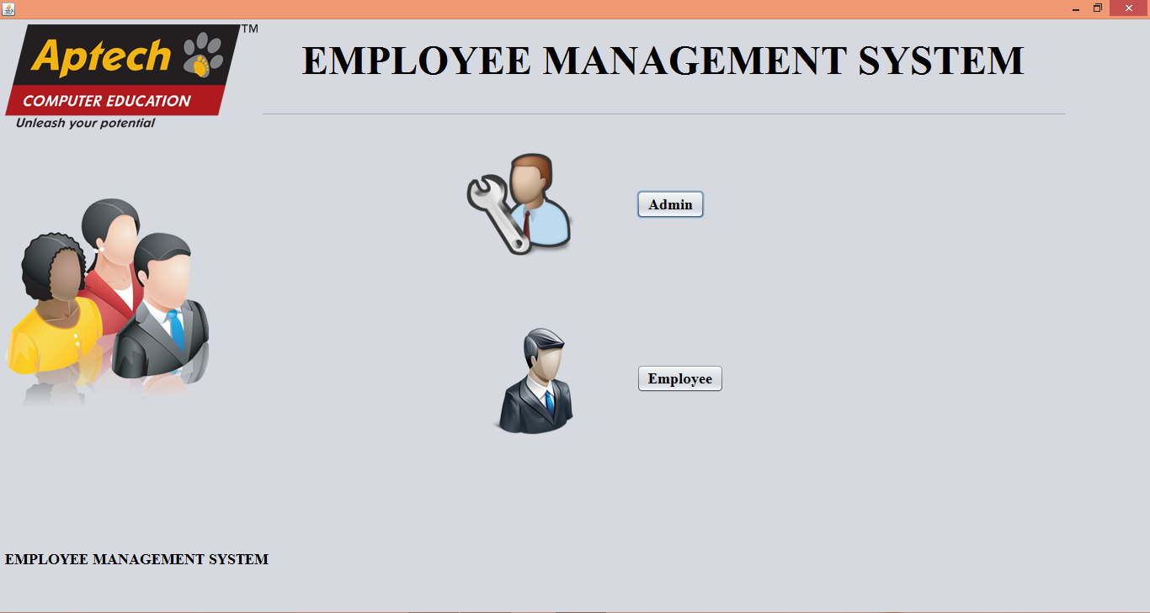**MAIN FRAME**

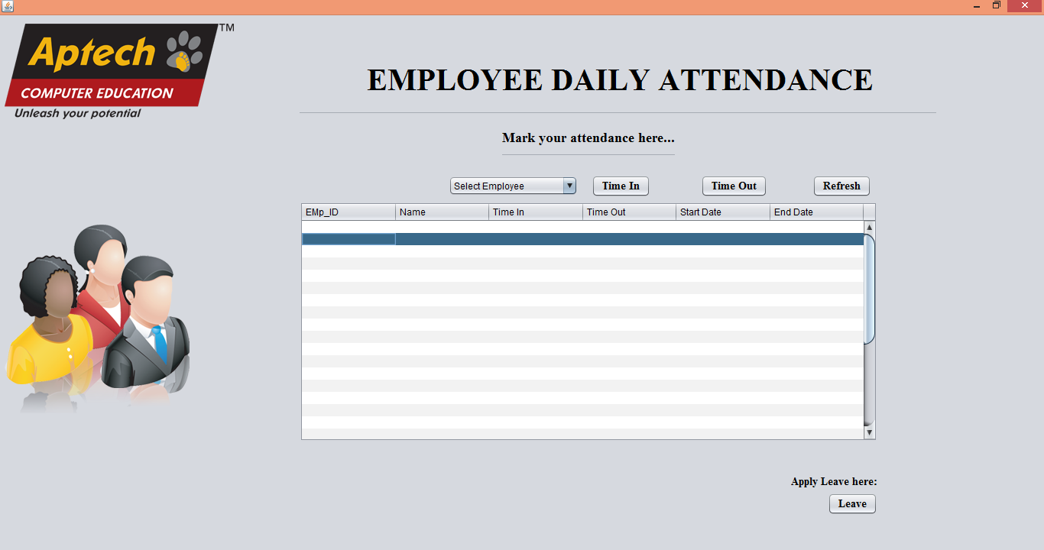**Employee-Employee Attendance**

**Admin-Login Page**

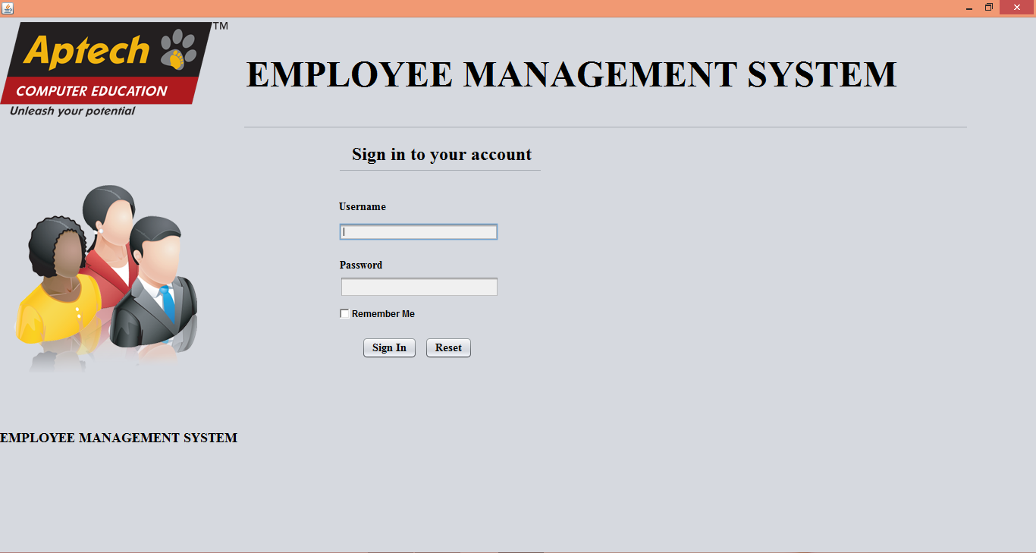

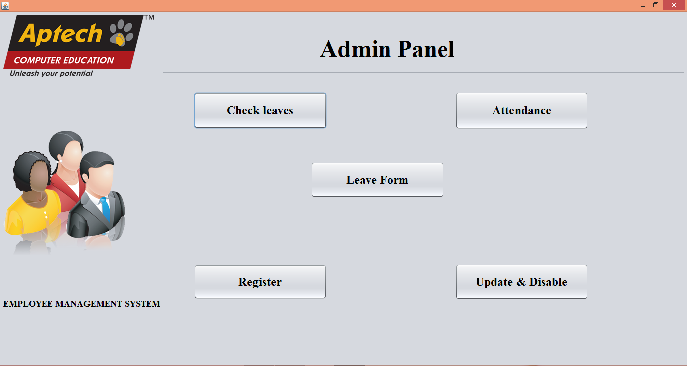**Admin-Login page-Admin Panel**

**Admin-Login page-Admin panel-Check Leaves**

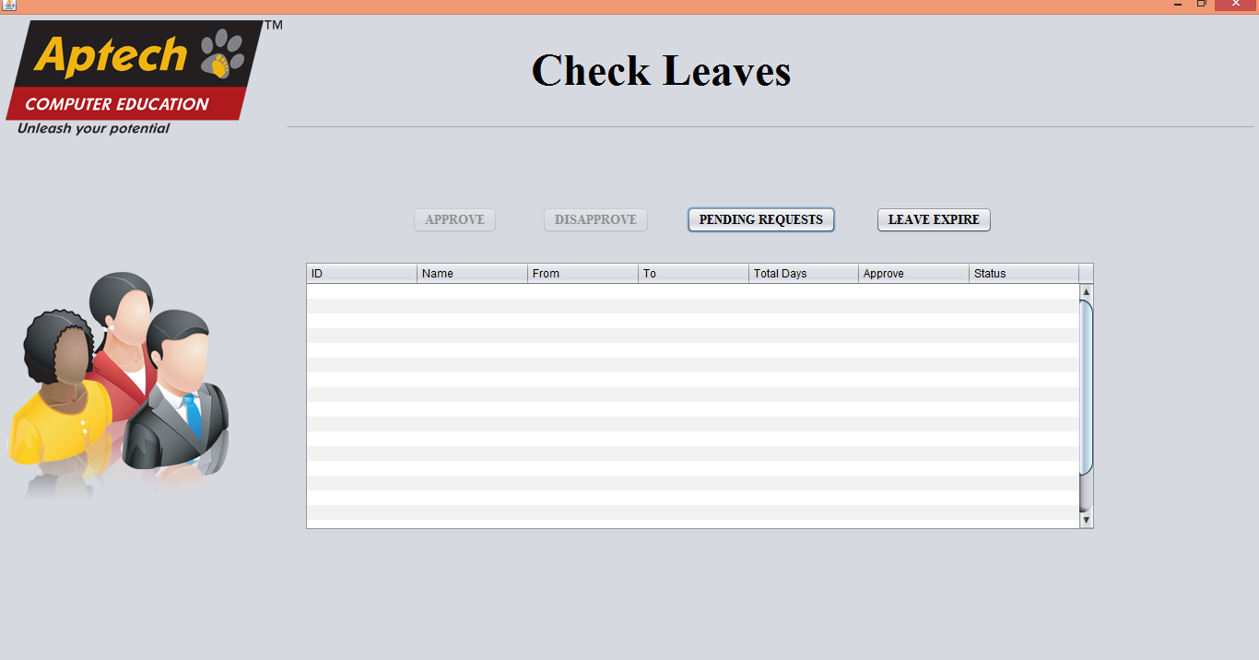

**Admin-Login page-Admin panel-Attendance**



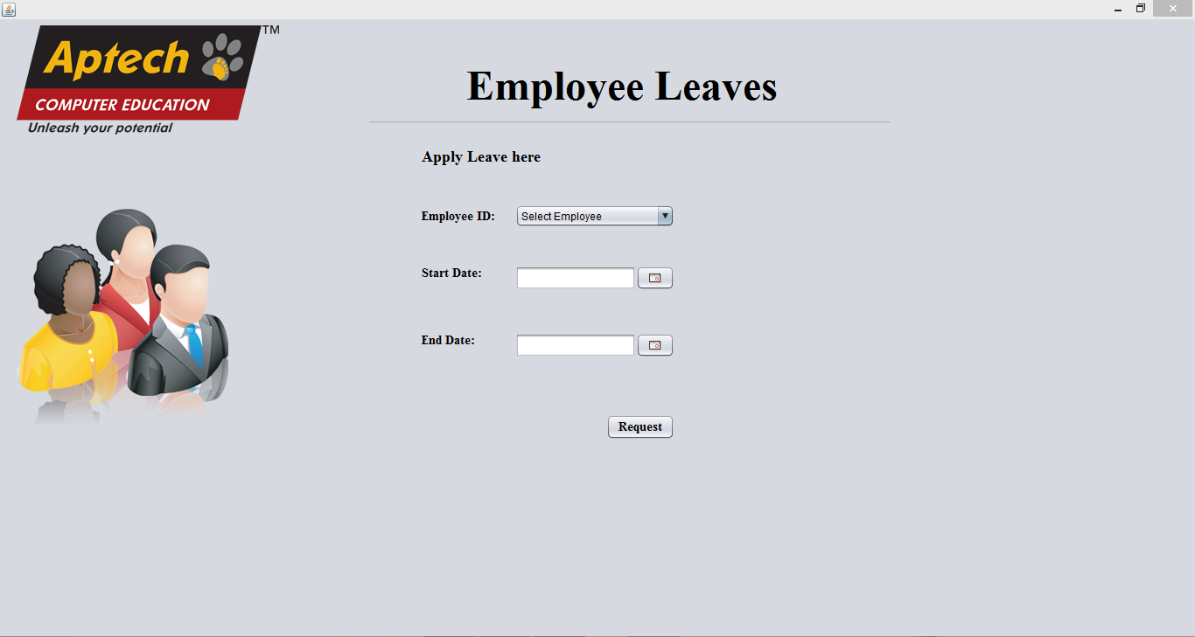**Admin-Login panel-Admin panel-Leave Form**

**Admin-Login panel-Admin panel-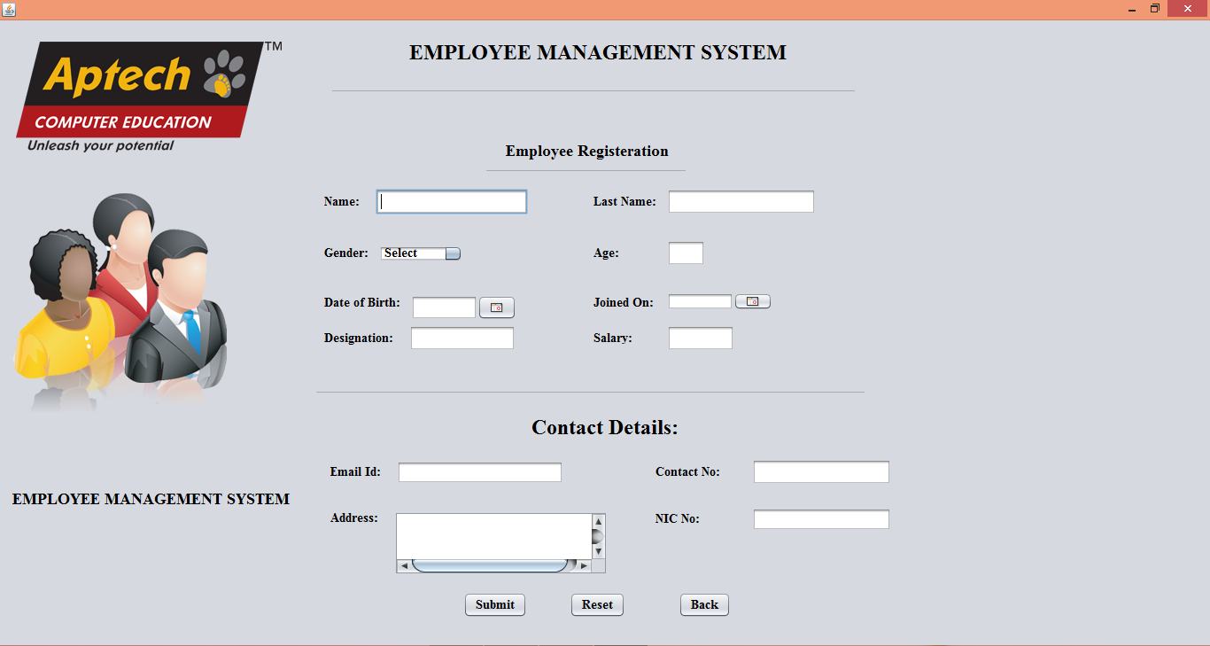Register**

**Admin-Login panel-Admin panel-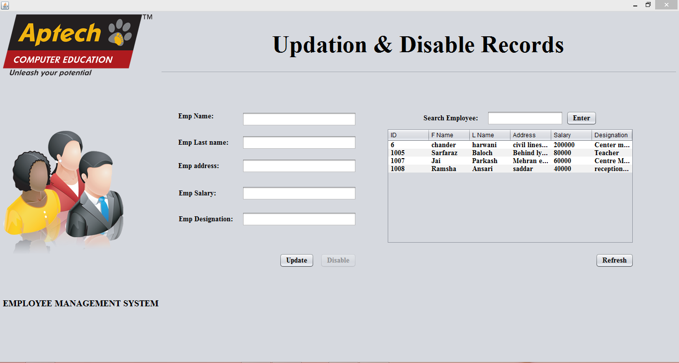Update And Disable**